Guidelines for Extended Abstract Preparation for the 20th Japan-Korea Symposium on Catalysis

First author's first name and family name1, Second author's first name and family name2, ...

1First author's affiliation, City, Country

2Second author's affiliation, City, Country

...

*E-mail: Corresponding author's e-mail

The scientific program in the 20th Japan-Korea Symposium on Catalysis will cover all aspects of catalytic research ranging from fundamentals to applications. The symposium will consist of a young scientist (student) program and a main symposium that includes plenary, keynote and contributed presentations and poster sessions. The official language of the symposium will be English. Participants who are interested to contribute a paper to the symposium are requested to send an abstract that includes title of the paper, author(s), affiliation(s), e-mail address of corresponding author, texts and references. **The abstract and submission form** should be submitted by e-mail (20JKSC@ees.hokudai.ac.jp). Followings are the guidelines for abstract preparation and submission.

Abstracts must be submitted via e-mail by December 20 (Fri.), 2024. The acceptance of papers will be announced around early March 2025.

The size of paper should be A4 (210 mm × 297mm). The abstract should be one page, including figures, with page margins of 20 mm all around. The font type should be “Times New Roman”, “Times” or similar one for all parts including the title and references, with single spaced lines. All text must be in a two-column format. Columns are 8 cm wide and 1 cm space between columns.

Title of the paper (14 points, first letters caps, centered) could span in maximum three rows, and is followed by one blank line. Author’s names are written (12 points, centered) with the order of first name and family names. Authors are separated by commas and marked with superscript when necessary to distinguish authors from different affiliations. The presenting author’s name should be underlined. Author’s affiliations (12 points, italic, centered) are written in separate rows. Abstract text (12 points) is justified at two sides; paragraphs are indented by 5 mm tab. References should be indicated in the text in square brackets, such as [1-3] and listed at the end of the paper (11 points). Figures should be high quality graphics, line drawings, or black and white photographs, and placed preceding the reference list. Acknowledgement should be addressed as a last paragraph of the text body.

夜の街のイラスト

Fig.1 BIG SHIP in Yonago city.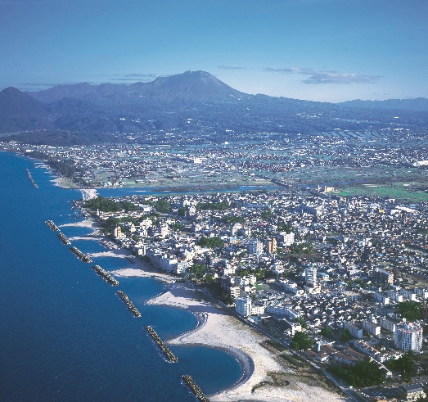

Fig. 2 Mt. Daisen and Yumigahama beach.

In the reference list, periodicals [1], books [2], multi-author books [3] and proceedings [4] should be cited in accordance with the following examples:

**REFERENCES**

[1] M.S. Jarrell, B.C. Gates and E.D. Nicholson, J. Am. Chem. Soc., 100 (1978) 5727.

[2] L.R. Snyder, Principles of Adsorption Chromatography, Marcel Dekker, New York, 1968, p. 201.

[3] R.D. Marshall and A. Neuberger, in A. Gottschalk (Editor), Glycoproteins, Vol. 5, Part A, 2nd Ed., Elsevier, Amsterdam, 1972, Chap. 3, p. 215.

[4] G.C. Bond and P.B. Wells, Proc. 4th Int. Symp. Scientific Bases for the Preparation of Heterogeneous Catalysts, Louvain-la-Neuve, 1-4 Sept. 1986, paper No. 2.